**How to Choose Best Laptop for Programming?**

**RAM**

It is the first most important thing that you should look. A laptop with 8GB RAM is an ideal choice but 16GB RAM would the best choice. If your budget is too low then you can go with 4GB RAM also.

Believe me it really sucks working on a low performance machine. Earlier I used to do android app development on a laptop with 4GB RAM. It was so annoying because everything works really slow.

So I would highly recommend you a 16GB RAM laptop if you are a mobile app developer.

**Best Choice:** 16GB RAM

**Ideal Choice:** 8GB RAM

**Low Budget Choice:** 4GB RAM

**Processor**

Good processor and RAM should be your highest priority while choosing a laptop for programming. As a programmer or developer we have to do multitasking. When I do programming or development I have to open few IDEs along with a browser with several tabs opened. For such purpose a good processor is required.

A laptop with i5 processor is an ideal choice. You can go with i7 processor if you have huge budget and for low budget you can go with i3 processor.

**Best Choice:** i7 Processor

**Ideal Choice:** i5 Processor

**Low Budget Choice:** i3 Processor

**Graphic Card**

Integrate graphic card is not necessary until you are not doing game development or some high graphics related work. But if you are a game developer then you must go with a laptop with external graphic card.

**Best Choice (Specially For Game Developers):** External Graphic Card (2GB or 4GB)

**Ideal and Low Budget Choice (For Other Developers):** Integrated Graphic Card

**Storage**

SSD and HDD are two storage types that laptops have. SSD gives faster performance but costlier than HDD. Its great if you can afford a SSD storage type laptop. But if you can’t then go with HDD and later on you can use some external SSD storage.

**Battery Life**

If you mostly work at places where power supply is not available then you must choose a laptop with huge battery life. Otherwise these days almost all laptops come with moderate battery backup.

You can get custom programmer [laptop stickers](https://www.stickeryou.com/products/laptop-stickers/190/) at www.stickeryou.com.

Below I have shared some laptops that I believe are good for programmers in India. Even if you don’t like any of them you can consider above points to pick a best laptop according to your usage.

**10 Best Laptops for Programmers and Developers in 2019**

**1.**[**Dell Inspiron 5570**](https://amzn.to/2Cdjuue)

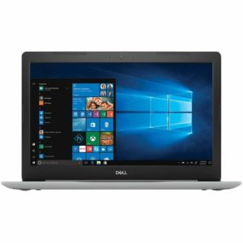

**Price:**Rs. 82,499

**RAM:**16GB DDR4

**Processor:**Core i7 8th Gen 8550U

**Graphic Card:**4GB AMD Radeon 530

**Storage:**2TB HDD

**2.**[**Acer Nitro Core i7 8th Gen**](https://amzn.to/2SMFeUQ)

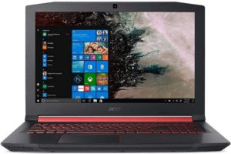

**Price:**Rs. 75,990

**RAM:**8GB

**Processor:**8th Gen i7

**Graphic Card:**4GB NVIDIA GeForce

**Storage:**1TB/128 GB SSD

**3.**[**Apple MacBook Air Core i5**](https://amzn.to/2AIvkfR)

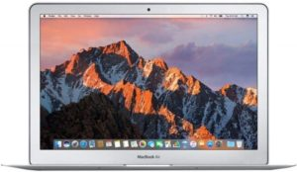

**Price:**Rs. 67,990

**RAM:**8GB LPDDR3 RAM

**Processor:**1.8GHz Intel Core i5

**Graphic Card:**Intel HD Graphics 6000

**Storage:**128GB

**4.**[**Asus TUF Gaming FX504GD-E4021T**](https://amzn.to/2Rq5yHT)

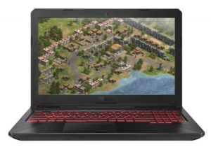

**Price:**Rs. 59,990

**RAM:**8GB DDR4

**Processor:**2.3GHz Intel Core i5-8300H

**Graphic Card:**4GB NVIDIA GeForce

**Storage:**1TB

**5.**[**Lenovo Ideapad 330 Intel Core i5 8th Gen**](https://amzn.to/2TJBhjS)

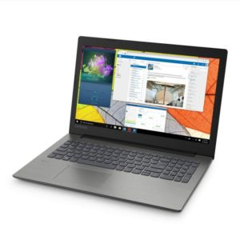

**Price:**Rs. 51,990

**RAM:**8GB

**Processor:**8th Gen Intel i5-8250U

**Graphic Card:**AMD Radeon 530 4GB GDDR5 Graphics

**Storage:**1TB

**6.**[**HP 15 Intel Core i5 8th Gen**](https://amzn.to/2TF1mAv)

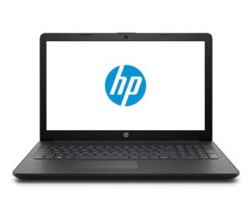

**Price:**Rs. 47,690

**RAM:**8GB DDR4

**Processor:**8th Gen Intel Core i5-8250U

**Graphic Card:**Nvidia GeForce MX110 2GB

**Storage:**1TB HDD

**7.**[**Asus VivoBook 15.6 FHD**](https://amzn.to/2SQmMdW)

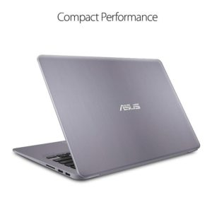

**Price:**Rs.53,490

**RAM:**8GB DDR4

**Processor:**Core i5 Processor – 8th Generation

**Graphic Card:**2GB ddr5 nvidia

**Storage:**1TB HDD

**8.**[**Asus Vivobook X507UA-EJ274T**](https://amzn.to/2Cch3rO)

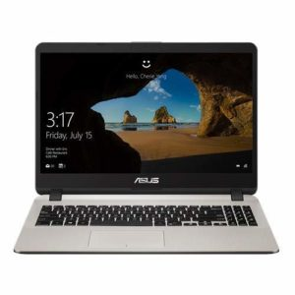

**Price:**Rs. 35,990

**RAM:**8GB DDR4

**Processor:**Intel Core i3-7020U

**Graphic Card:**Integrated Intel HD Graphics 620

**Storage:**1TB HDD

**9.**[**HP 15 Core i3 7th gen**](https://amzn.to/2CchxhC)

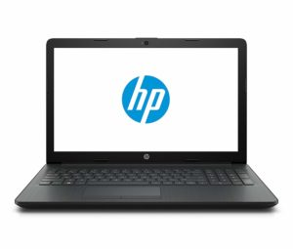

**Price:**Rs.28,990

**RAM:**4GB DDR4

**Processor:** 7th Gen Intel i3-7020U

**Graphic Card:**Integrated Graphics

**Storage:**1TB HDD

**10. [Lenovo Ideapad 330 81G2004XIN](https://amzn.to/2ROBEMR" \t "_blank)**

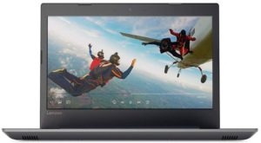

**Price:**Rs.28,950

**RAM:**4GB DDR4

**Processor:**Core i3 7th Gen

**Graphic Card:**Integrated Graphics

**Storage:**1TB 5400rpm hard drive